Knowledge Watchkeeping
Open Book

Participant Name |  | Signature
RTO Name / Code | Seafood & Maritime Training 7074 | Date of Assessment
Course Name | Coxswain Deck
UoC partially mapped to this assessment | MARI003 Comply with regulations to ensure safe operation of a vessel up to 12 metres
Participant Instructions on Assessment | This assessment is to be completed by participants and will be used as evidence of the participant achieving competency.  - Write your name, date and signature at the top of this Assessment  - This assessment is to be completed within the allocated time of 45 minutes and is an open book assessment.  - A satisfactory answer to each question is required as acceptable  - Write your answers on this Assessment in the spaces provided. If you need more space to write your answer, use a blank sheet of paper obtainable from your trainer  Resources Required:  - Cockpit Companion
Assessment  Outcomes: | S – Satisfactory  NS – Not yet Satisfactory
Watchkeeping |  |  |  |  | S / NS
Within the scheduled duration of the training and assessment if the participant is found not satisfactory, please fill in a Participant Development Report.
In finding the participant satisfactory they have met the requirements of this assessment:

Trainer/Assessor Name: ____________________ Signature: ____________________________

Date: ______________________

Assessor Notes:  While undertaking the scheduled training | E.g. Q1 – needs a more detailed answer.  ________________________________________________________________________________________________________________________________________________________________________________________________________________________________________________________________________________________________________________________________________________________________________________________________________________________________________________________________________________________________________________________________________________________________________________________________________________________________________________________________________________________________________________________________________________________________________________________________________________________________________________________________________________________________________________________________________________________________________________________________

Watchkeeping | S | NS

How do you determine if a risk of collision exists with another vessel.

You are the Coxswain of a power-driven vessel making way. The following lights are seen ahead on a steady bearing. Identify the type of vessel and your actions required by the Collision Regulations

I003-PC1.1, 3.1, 3.2, P5, K8, K11
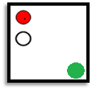

Type of vessel__________________________________________

Are you the stand-on or give-way vessel _____________________

Course of action_______________________________________________________


Type of vessel __________________________________________

Are you the stand-on or give-way vessel_________________________

Course of action___________________________________________
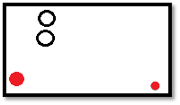

Type of vessel _______________________________
Figure 1ARW

Are you the stand-on or give-way vessel __________

Course of action________________________________________

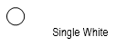
List two (2) types of vessels this light could be:

- ____________________________________________________

- ____________________________________________________

Complete the blanks in the table below.

Vessel lights | Vessel type and Operation | Day Shapes
 |  | 
 |  | 
Vessel Towing
>200m

In Restricted Visibility

Sound signals  (fill in the blank) | Vessel Type and Operation  (fill in the blank)
 | Vessel at anchor <100m
1 Prolonged + 2 Short Every 2 minutes

A vessel in restricted visibility hears a fog signal consisting of one (1) prolonged blast at intervals of about 2 minutes. What vessel is this. (Circle your answer)

A power-driven vessel underway, but stopped and making no way through the water.

A power-driven vessel making way through the water.

A vessel being towed by another vessel
- A Vessel NUC

A power-driven vessel in sight of a sailing vessel makes a sound signal consisting of (2) two short blasts. What does this mean. (Circle your answer)

I am altering my course to port

I am altering my course to starboard

I am operating astern propulsion

Your intentions are not understood
- What type of mark is this. ____________________________

In which direction is Safe Water. _______________________

What colour is the light . ______________________

What is the light flashing sequence. _____________________________

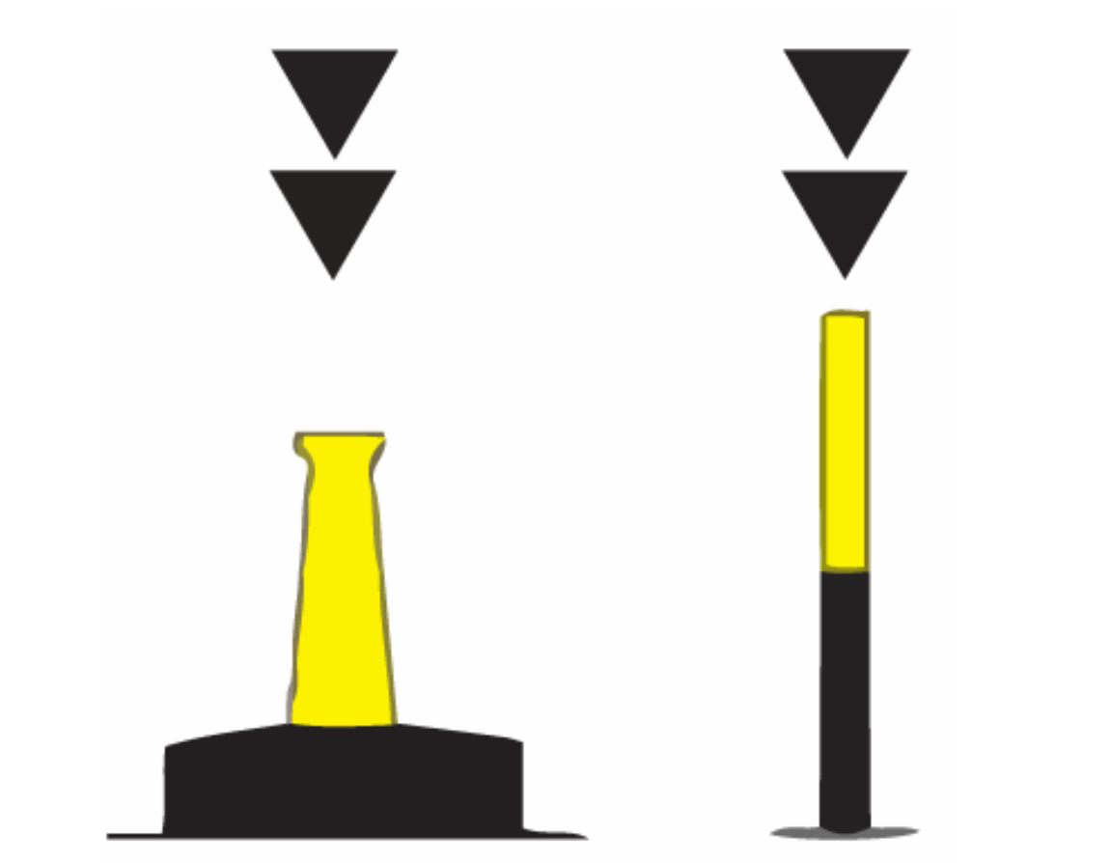

- What type of mark is this.
_____________________________
What is the light colour and Rhythm.
______________________________

